**Setting up and using the Merge Tools Add-in**

**Do NOT open the MergeTools – 20150422.dotm file.** (There are no user serviceable parts inside and it should NOT be used as the basis for creating your mail merge main document.)

The MergeTools – 20150422.dotm file needs to be saved in the Word Startup folder. In Windows Vista and Windows 7, 8 or 8.1, and 10, the default location for that folder is

C:\Users\[User Name]\AppData\Roaming\Microsoft\Word\STARTUP

If you do not see the AppData folder: -

In Windows 7, - In Windows Explorer, click on the Organize drop down and then on Folder and search options and in the Folder Options dialog, go to the View tab and select the item "Show hidden files, folders, and drives".  While there, it is a good idea to uncheck the box for "Hide extensions for known file types".

In Windows 8, 8.1 or 10, in the File Explorer, click on Options on the View tab of the ribbon and then on the View tab in the dialog that appears and select the item "Show hidden files, folders, and drives".  While there, it is a good idea to uncheck the box for "Hide extensions for known file types".

When that has been done and Word is started\re-started, the tab shown below will be added to the Ribbon:

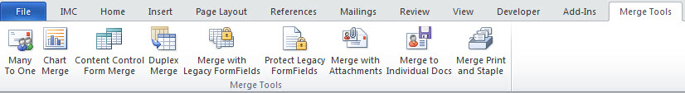

The requirements for using the system are:

1. The mail merge main document must be of the Letters type, though that does not mean that the output cannot be sent as an e-mail message.
2. For the Many To One, Merge with Attachments and Merge to Individual Docs utilities, the data source may be either a table or query in an Access database, or in the form of an Excel worksheet and that worksheet must be the first sheet in the Excel workbook. If the data is on some other sheet, you can easily move that sheet so that it is the first sheet in the workbook by clicking on the sheet tab and dragging it to the left. For the Chart Merge utility, download the Mail Merging with Charts document that is also on that page of my OneDrive for additional requirements of the data source for use with that utility
3. For a data source in the form of an Excel worksheet, the field names must be in the first row of the worksheet and there must be a field name in all of the cells in that row that are within the range of columns that contain the data.
4. For both types of data source, the field names must contain only alphanumeric characters (No @,#,$,%,&,(,), etc) and the field names must not start with a numeric character (0-9). The number of characters in the field names, including spaces, must not be more than 40.
5. For a data source in the form of an Excel worksheet, the data must start in the second row of the worksheet and there should be no empty rows within the range of data that is to be processed.
6. If there are multiple addressees in either the To or CC fields of the data source, the email addresses need to be separated by a semi-colon.

NOTE: The MergeTools applications cannot handle “Compound” MergeFields such as the «AddressBlock» or «GreetingLine». Instead of using those fields, you will need to insert the individual merge fields.

You may also want to read:

1. the Merging with Attachments document that explains how the system is used. It is not actually necessary to have separate attachments as the facility can be used to send just the documents created by the merge itself as attachments, either as the body of the message itself or in the form of Word files or .pdf files.
2. the Mail Merging with Charts document that explains how you must set up the Excel Data Source and the Mail Merge Main document to be able to execute a merge with a Chart that is unique to each record in the data source.
3. the Using the Many to One Facility document that describes how to use that facility.

If you need assistance with the use of these utilities, contact me via [dkr@mvps.org](mailto:dkr@mvps.org) or [dougrobbinsmvp@gmail.com](mailto:dougrobbinsmvp@gmail.com)

The Merge Tools Utilities have been developed so that they will meet the needs of most users. I am however available to create customized versions of them if the generic version does not do exactly what you are after.